FLC ACTING CLUB
Instructor Bios and Course Descriptions
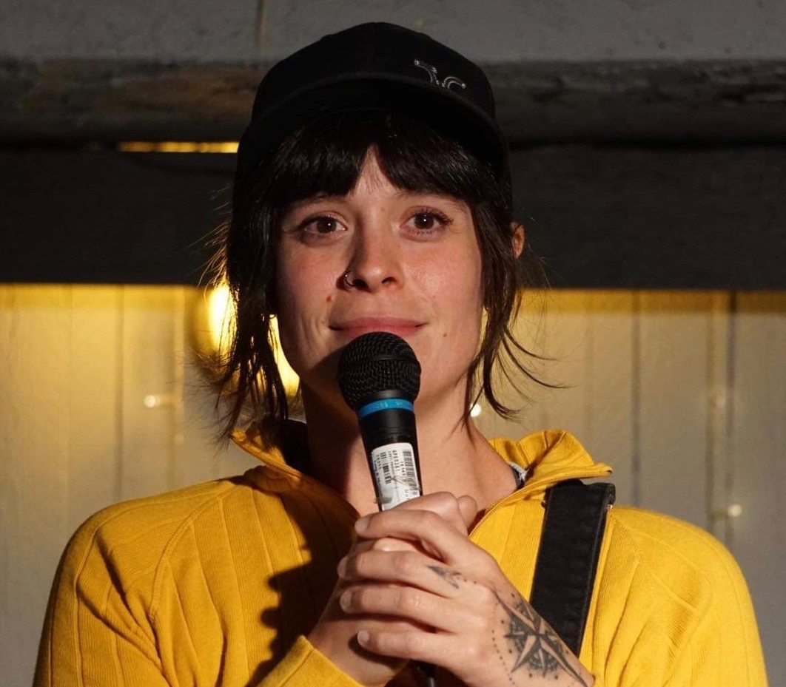  Instructor: Tarah Buchanan | Creator of Top Shelf Comedy Productions, Tarah Buchanan started doing stand-up comedy in Toronto in 2014 and hasn’t looked back. She has produced and hosted hundreds of shows, hosted the SNL cast at the Great Outdoors Comedy Festival in June 2022 and celebrated her Fish Bowl Show’s 3rd Year Anniversary in August 2024. With a decade of practical application knowledge, Tarah has learned the do’s and don’ts of stand-up comedy seemingly the hard way and has mastered the concept of work “smart” not “hard”. Working to demystify the world of stand-up comedy, she tears down walls, gate- keepers and “too cool for school” mentalities to help pave the way for the future of stand-up comedy.  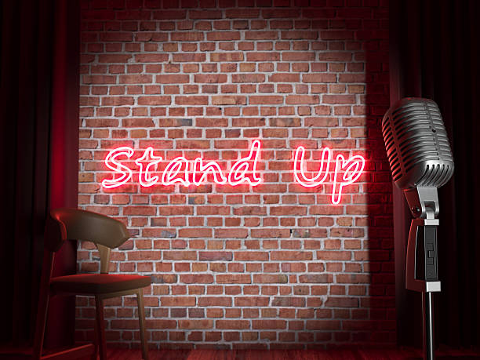
Stand-Up Comedy

The course will be taught over a 6-week duration where first timers and old timers will be putting together their first or maybe their tenth, 5 minutes of stand-up comedy. Getting noticed in the scene and booked on bigger and bigger shows means you have the tightest, funniest and most unique 5 minutes that you could possibly present to an audience. At the end of the course, students will be performing their 5 minutes at a comedy club recital that they have produced and put together themselves. Not only will you leave the course with a rocking 5 minutes of material, but also the “know how” to put together you very own show.

Hav
Instructor Bios and Course Descriptions (cont.)
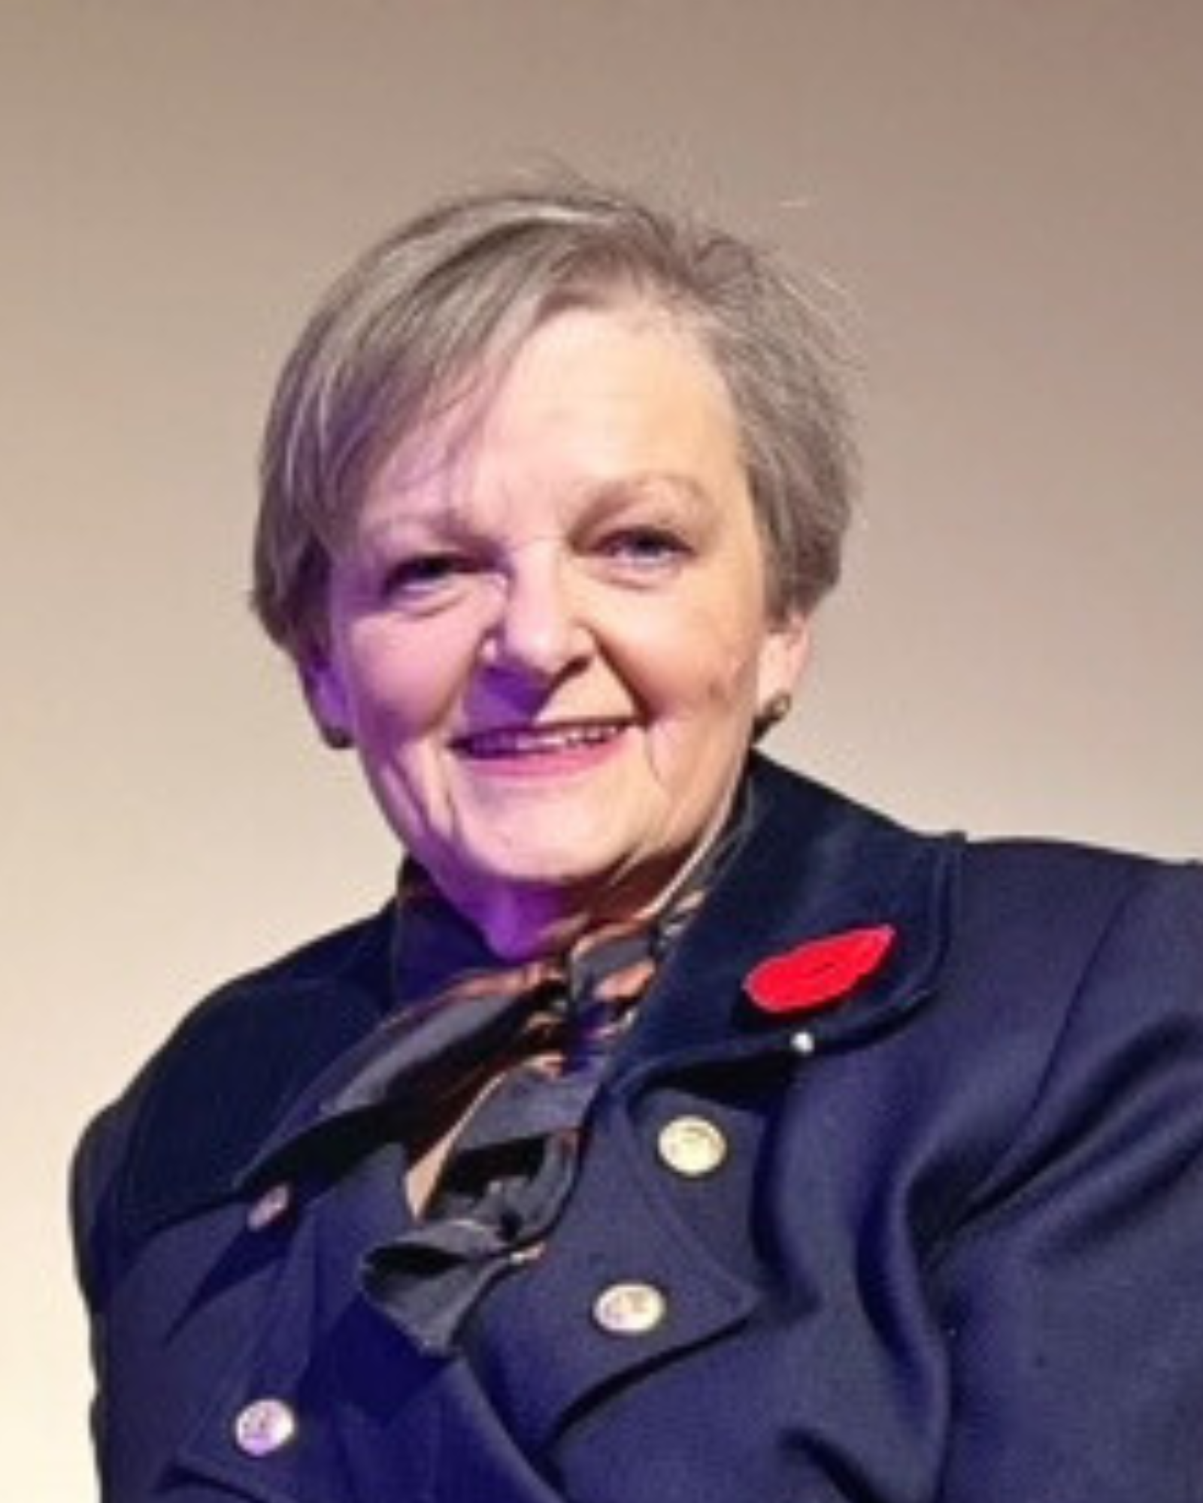  Instructor: P. Gail Whiteford | P. Gail Whiteford BFA (Drama) 1973, BEd (Sec) 1974. Gail graduated from U of C’s Drama Department in 1973. She taught Drama, English, and Public Speaking in Australia, Italy and Canada before retiring from the National Sport School in Calgary in 2006. She then taught Drama Education at U of C for six years. Gail presents Workshops all over Alberta in Makeup, Acting, Stage Violence: Swordplay, and Voice at schools and conventions. She has written three books on how to teach Makeup and Stage Violence, and five teaching manuals for Alberta Education. While in Calgary, Gail taught Drama classes at Unison at the Kerby Centre and Confederation Seniors Centre, and along with the classes presented murder mysteries, historical dramas and comedies for those communities. Currently, Gail is the Artistic Director of The Golden Unicorn Collective where she writes and directs shows for her company based on Canada's military history.


Introduction to Acting: Discovering What it Takes to Act!

Have you ever wondered what goes into a perfected stage performance? Over the duration of this course, we will explore: Introduction to Stage Acting/Improvisation and Areas of the Stage, Movement and Character, Voice and Character, Script Reading, Creating a Monologue for Auditioning and Scenes with Character.

Instructor Bios and Course Descriptions (cont.)
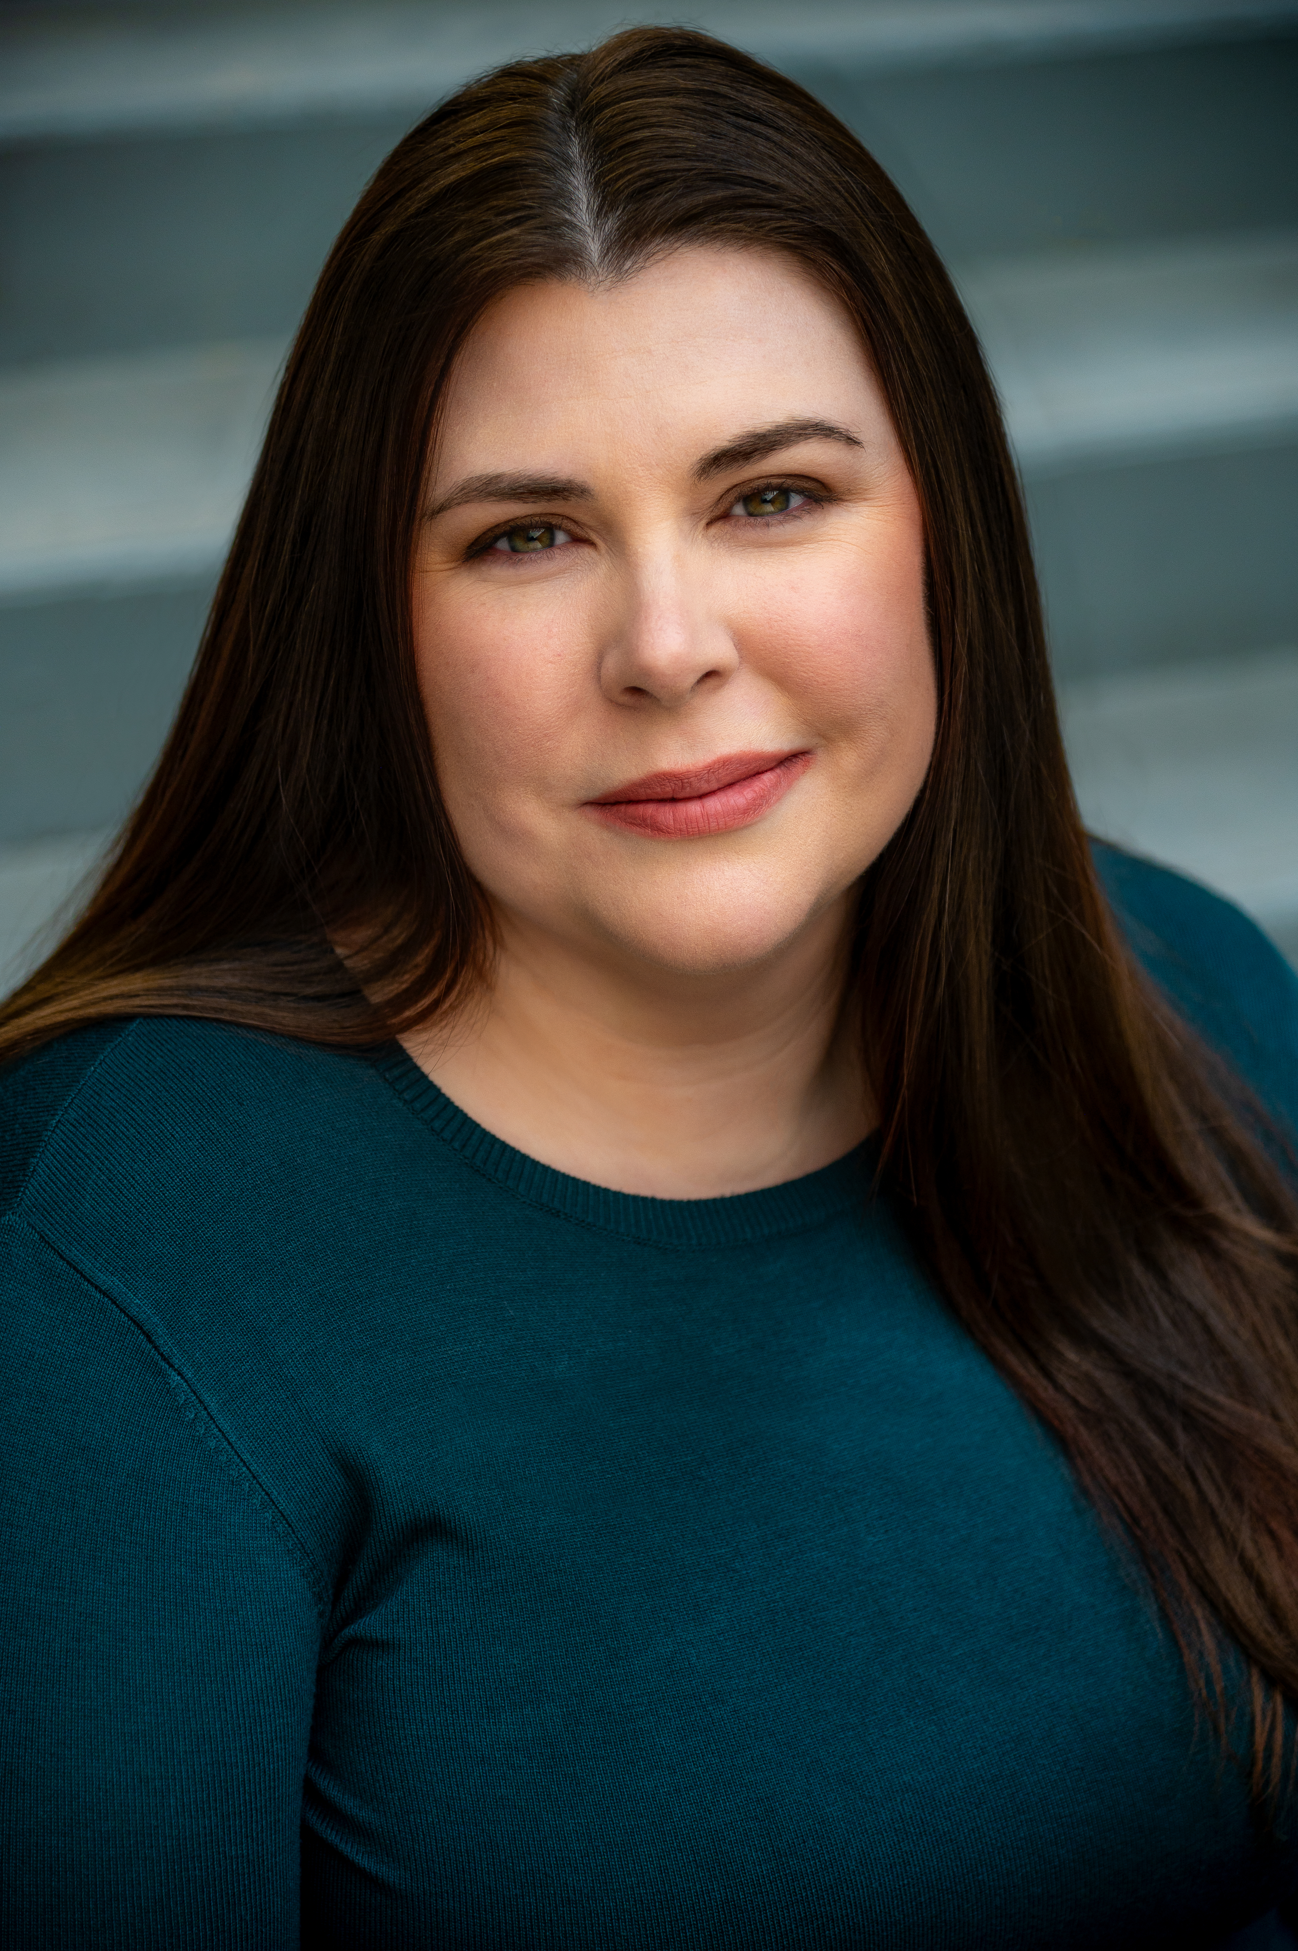  Instructor: Tamara Van Horne | Tamara is a Calgary based performer who is making her FLC Acting Club debut in Lost & Found: Beth’s Discovery. Favourite roles include Mrs. Tilford in The Children’s Hour, Flo Owens in Picnic, Dina Dranchuk in Recommend for Mercy, and the Assistant in Bobby Gould Goes to Hell.  Tamara is a graduate of the Master Class Program at Company of Rogues Actors’ Studio and currently the Artist Services Manager for the Calgary Fringe Theatre Festival and Associate Producer at Urban Stories Theatre where she has both directed and acted in plays. She is excited to be sharing her knowledge on Acting with FLC Seniors Acting Club.
Scene Study

For this class, participants will go deeper into the details of a scene, and learn character development in greater detail. They will be partnered with someone from class and assigned a scene to work on during the course. They will also participate in a final performance for the last class. Students will be learning techniques and skills from Stella Adler’s The Art of Acting.

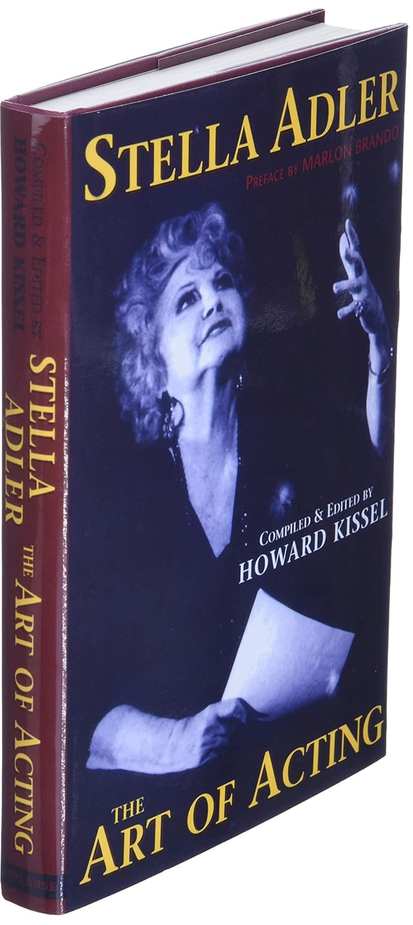

Instructor Bios and Course Descriptions (cont.)
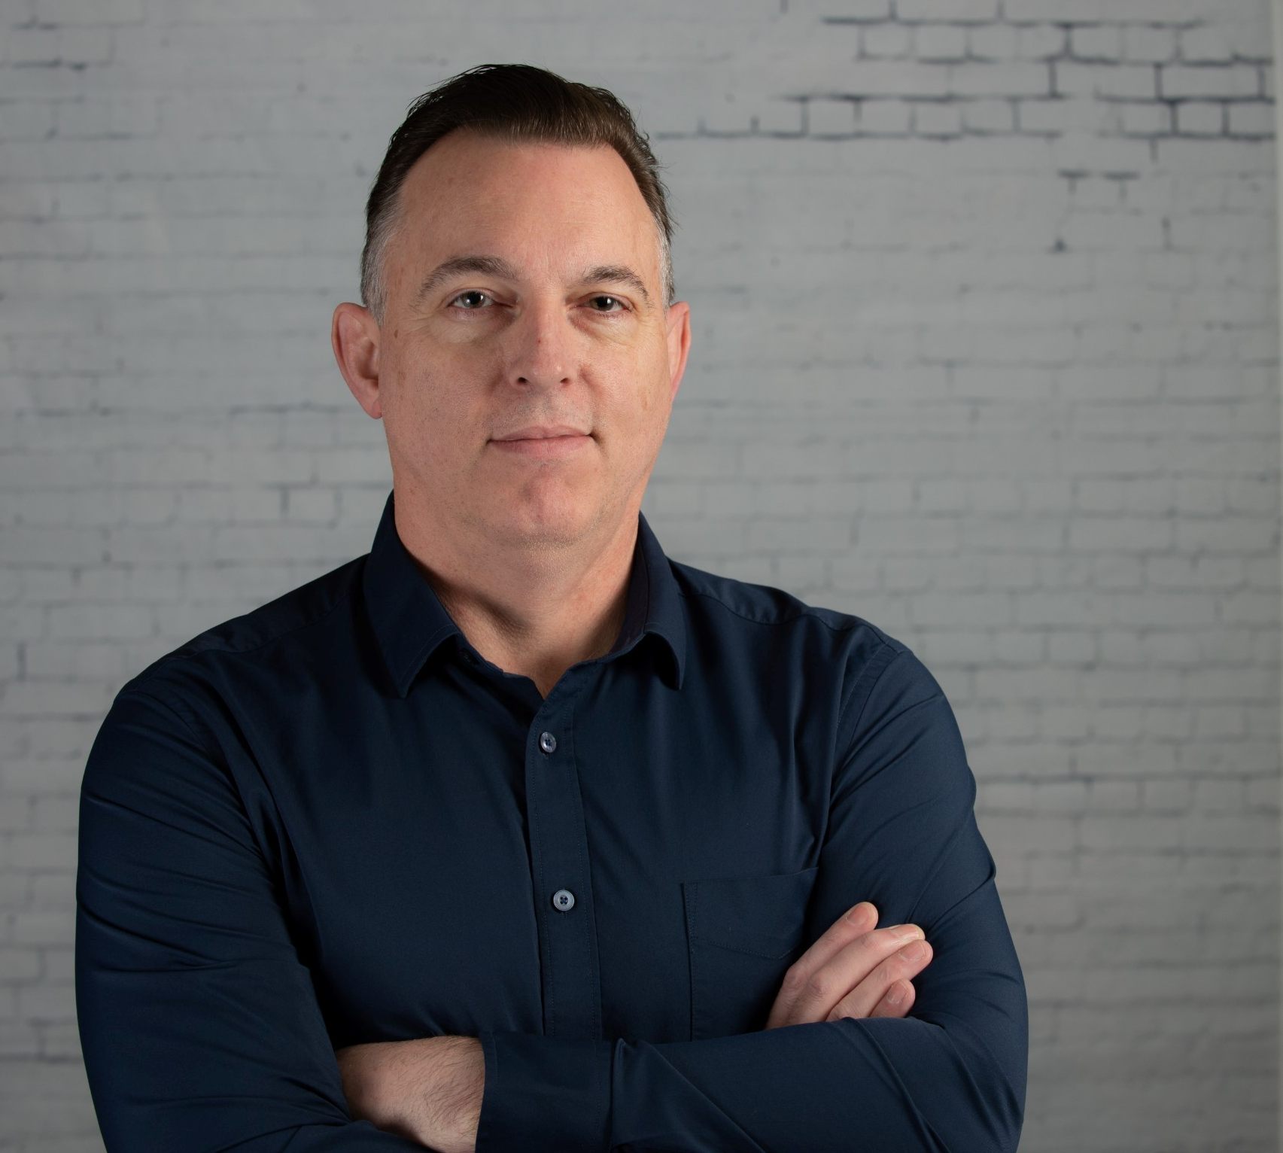  Instructor: Barry Piercey | Barry is a comedian, actor, director, and improviser. Born and raised in Newfoundland, he now calls Calgary home where he lives with his wife, Jodie, and their two kids. Barry is an active member of the world-famous Loose Moose Theatre Company, where he found a new love in improvised comedy. He continues to perform in weekend improv shows and is actively involved teaching and directing in the Theatre.  In 2017 Barry decided to try his hand at stand-up comedy and booked his first Amateur spot. It did not go well…picture a plane crashing into a train that is going off the rails because of a mountain mud slide…and that was still better than that first set. It didn’t matter and he was hooked from the start.
Barry has been performing Stand Up Comedy ever since and has performed throughout Alberta and BC. He has performed at multiple Yuk Yuks, The Laugh Shop, Sonar and at Laugh Madness where he opened for Kojo Anim (runner up in Britain’s Got Talent 2019). Most recently he opened for Shaun Majumder on his “Love Tour” while in Calgary.
Barry continues to produce Taproom Comedy, a Pro-am show throughout the greater Calgary area with multiple partner venues. It all started with one venue, and one show….and now the next step is the Legends of Comedy series.
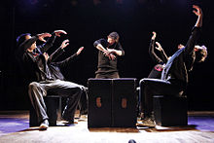

Improvisation

Participants will be introduced to some of the foundational techniques of improvisation that every actor needs to know to finetune their craft. This includes “yes and”, active listening, playing with status, establishing strong characters, using objects and exploring emotional range. So embrace your spontaneous self while you explore and practice these techniques to enhance your adaptability and capability as an actor.

